AVENTY Server Patching Automation

Process Definition Document (PDD)

CONFIDENTIAL

TABLE OF CONTENTS
1. Document Control
1.1 Version Control
1.2 Document Review and Sign-Off
2. General Process Description
2.1 Document Purpose
2.2 Process Summary
2.3 Applications Used
2.4 Inputs and Outputs
2.5 High-Level Process Flow
3. Exception Handling
3.1 Known Exceptions
3.2 Unknown Exceptions
4. Step-by-Step Process Documentation

1. DOCUMENT CONTROL
1.1 VERSION CONTROL
Version | Date | Description | Author
1.0 |  | Initial Draft

** Document version should be updated when shared with primary stakeholders. **
1.2 DOCUMENT REVIEW AND SIGN-OFF
Name | Business Role | Action | Date

2. GENERAL PROCESS DESCRIPTION
2.1 DOCUMENT PURPOSE
Here is the Document Purpose section:
**Document Purpose**
This document outlines the process for automating server patching using AVENTY Server Patching Automation. The primary purpose of this automation is to streamline the process of deploying security patches, including those from Microsoft, on a monthly basis. By automating this process, we aim to reduce manual effort and minimize downtime, while ensuring that our servers remain up-to-date with the latest security patches.
This document solves a business problem by providing an efficient and reliable method for managing server patching, which is critical to maintaining system security and stability. The automation process eliminates the need for manual intervention and reduces the risk of human error, thereby improving overall system reliability.
This document will be used by the IT team responsible for maintaining our server infrastructure, including those involved in configuring and scheduling AVENTY Server Patching Automation. It will also serve as a reference guide for troubleshooting and resolving any issues that may arise during the patching process.
2.2 PROCESS SUMMARY
**Server Patch Management and Deployment Process**
The objective of this business process is to ensure that Microsoft servers are properly patched and up-to-date with the latest security updates, applications, and configurations. This process involves using Aventy's Ivanti system for patch management and deployment, as well as Microsoft servers and Remote Desktop Protocol (RDP) for remote access.
**Main Steps:**
The process begins by logging into the Aventy console and selecting a server group, typically the 11th server group. The next step is to run a template on post-Tuesday, which is usually done monthly. This involves defining development and reboot templates, scheduling patching for the second Tuesday after the second Tuesday, and scanning servers for missing patches or not.
After scanning, a report is generated and sent to a configured email box. The report is then reviewed to check deployment status and identify any failures. If a failure occurs, the reasons are documented and escalated to the vendor team or application team if patching fails after three attempts.
**Applications and Systems Used:**
* Aventy console
* Ivanti (server management system)
* Microsoft servers
* Remote Desktop Protocol (RDP)
**Data Processed:**
* Server security patches
* Chrome patches
* Credential and access data for servers
* Scan report data
* Deployment status
**Expected Outcome:**
The expected outcome of this process is the successful deployment of security patches and Chrome updates to servers, as well as the identification and resolution of any patching failures. This ensures that Microsoft servers are properly patched and up-to-date with the latest security updates, applications, and configurations.
By following this business process, organizations can ensure that their server infrastructure is secure, reliable, and compliant with organizational policies.
2.3 APPLICATIONS USED
Application | Interface | Key Operation / URL | Purpose

2.4 INPUTS AND OUTPUTS
Inputs:
➤ No specific inputs identified
Outputs:
➤ No specific outputs identified

2.5 HIGH-LEVEL PROCESS FLOW
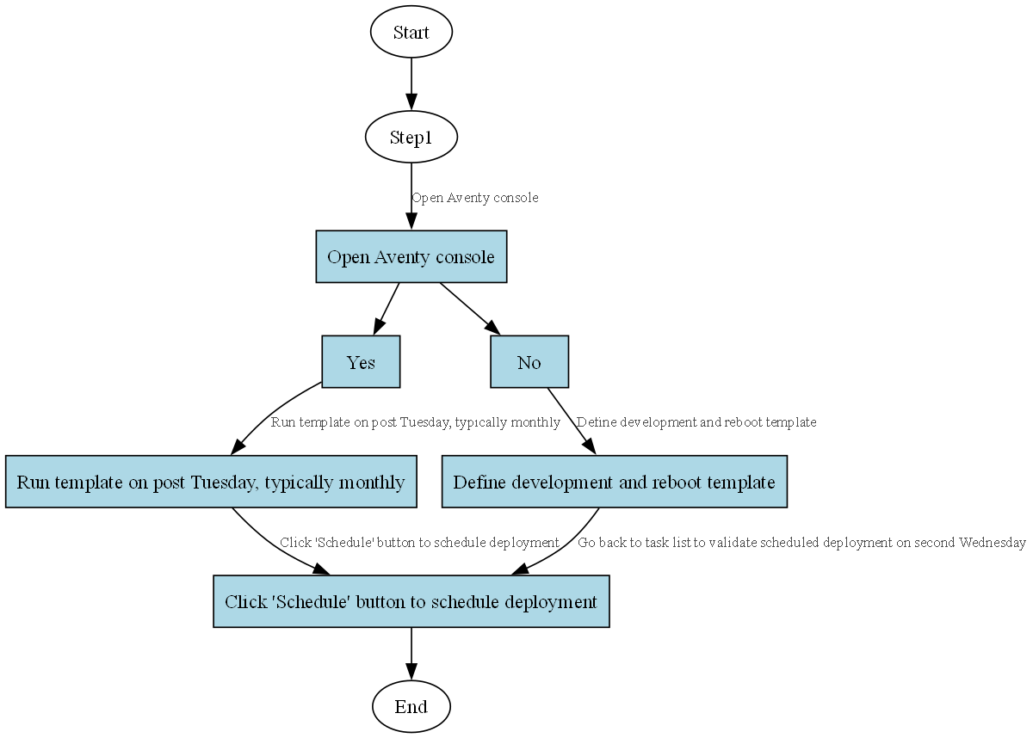
Figure 1: AVENTY Server Patching Automation Process Flow

3. EXCEPTION HANDLING
This section documents the different types of exceptions that may occur during process execution and how they should be handled.
3.1 KNOWN EXCEPTIONS
The following table lists process exceptions that have been identified and their corresponding handling procedures:
Exception Code | Description | Handling Action
EXC_001
EXC_002
EXC_003

3.2 UNKNOWN EXCEPTIONS
Unknown exceptions are errors that may occur during processing that were not previously identified. These will be logged and escalated according to the standard exception handling procedure.
Exception Code | Description | Handling Action
ERR_UNKNOWN | Unexpected system error | Log error, notify support team
ERR_TIMEOUT | Application timeout | Retry operation, escalate if persistent

4. STEP-BY-STEP PROCESS DOCUMENTATION
This section provides detailed step-by-step documentation of the process, including screenshots captured during process execution.
4.1 DETAILED PROCESS STEPS
Step 1
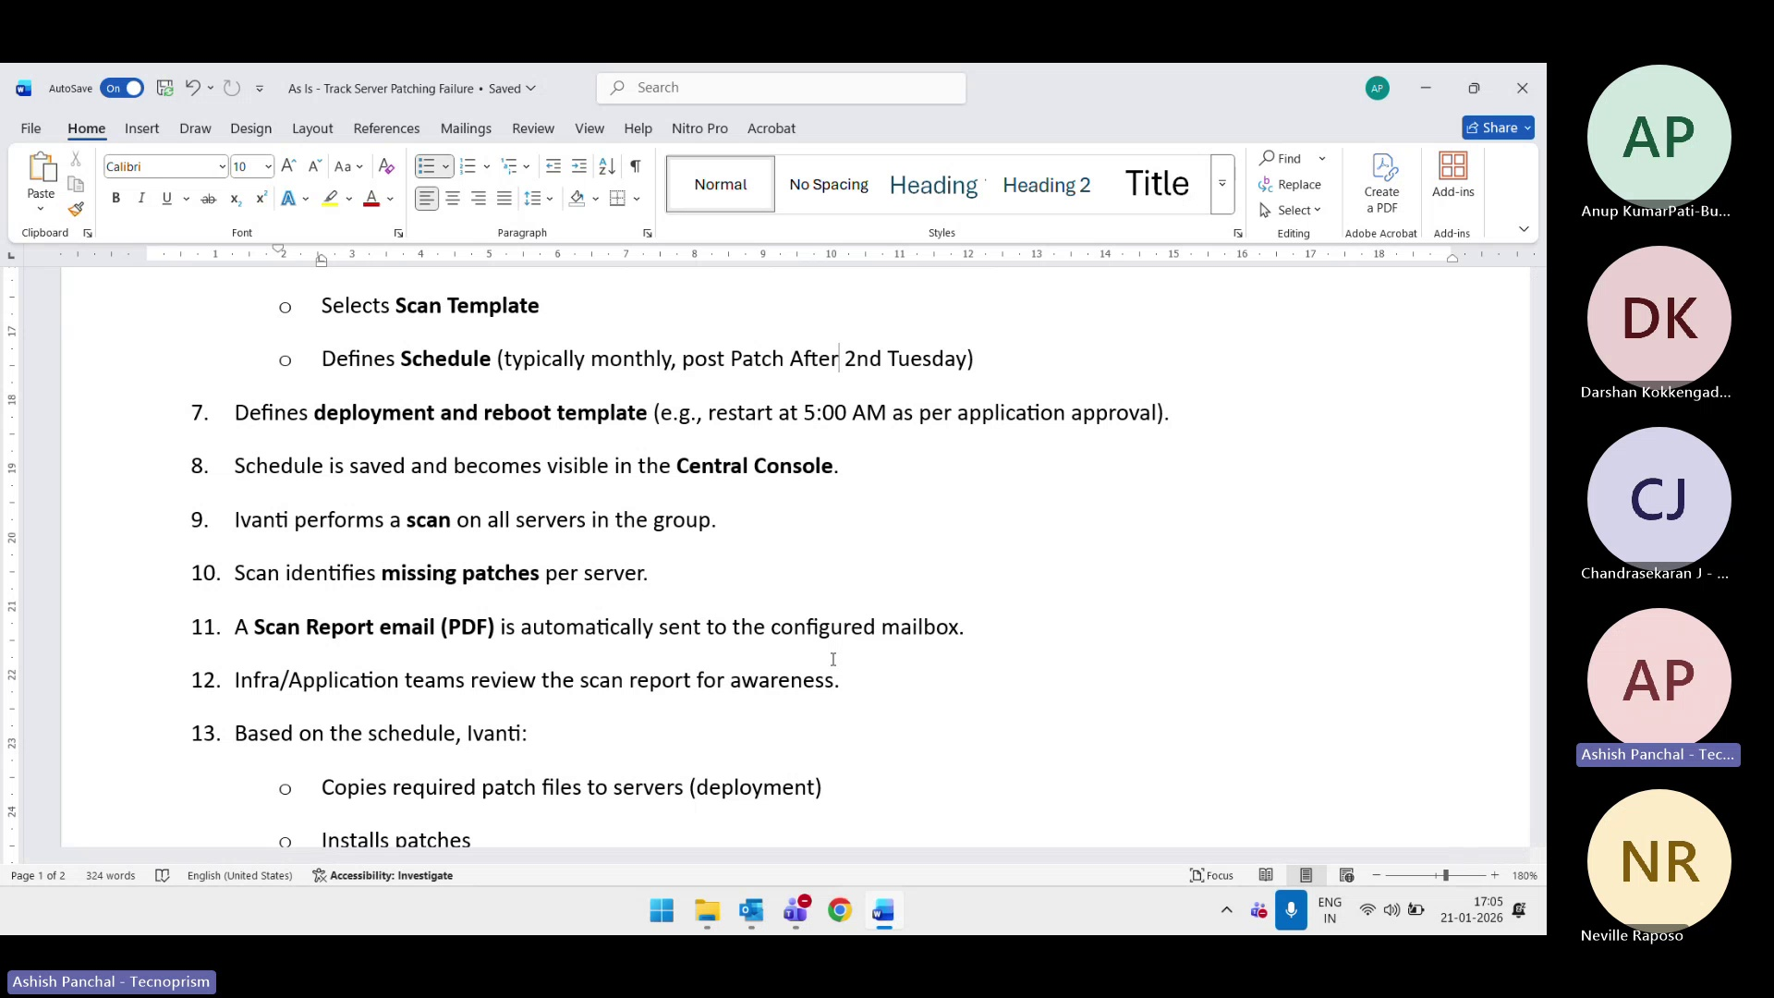
Here are the converted professional step descriptions:

Step 2
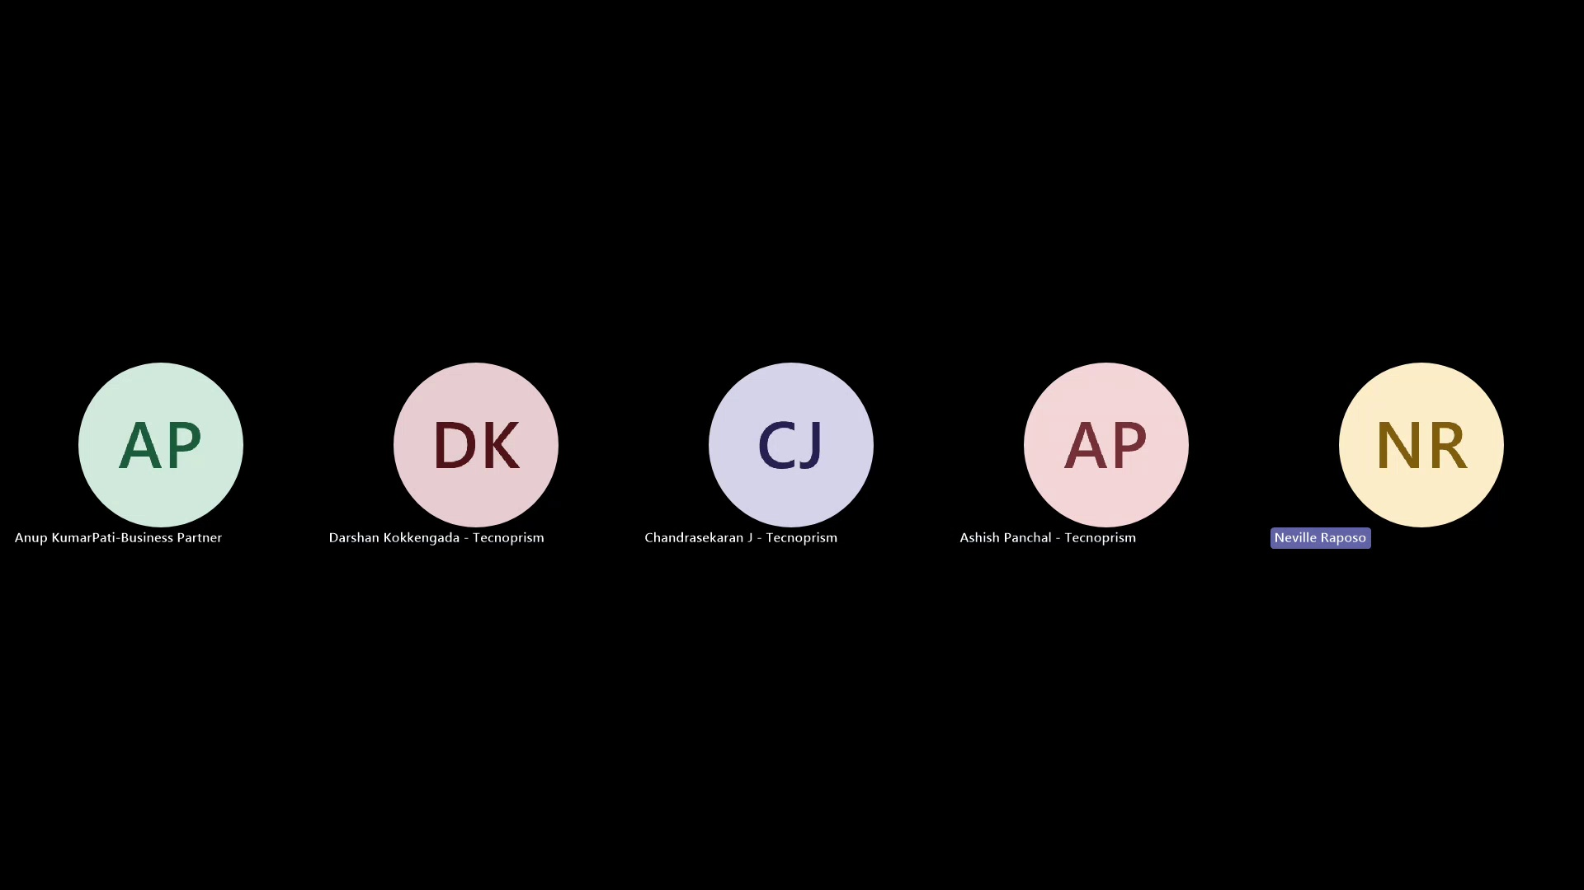
The system administrator initiates a comprehensive scan of all servers to detect and identify missing patches or updates.

Step 3
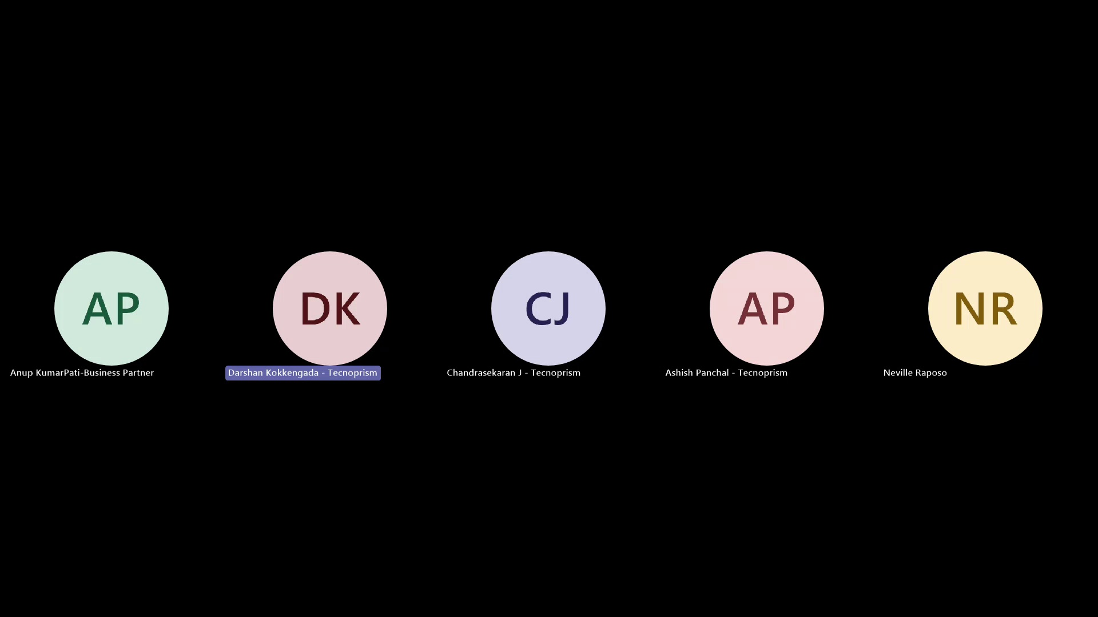
The user must determine which servers require deployment worker scanning, in order to proceed with the process efficiently.

Step 4
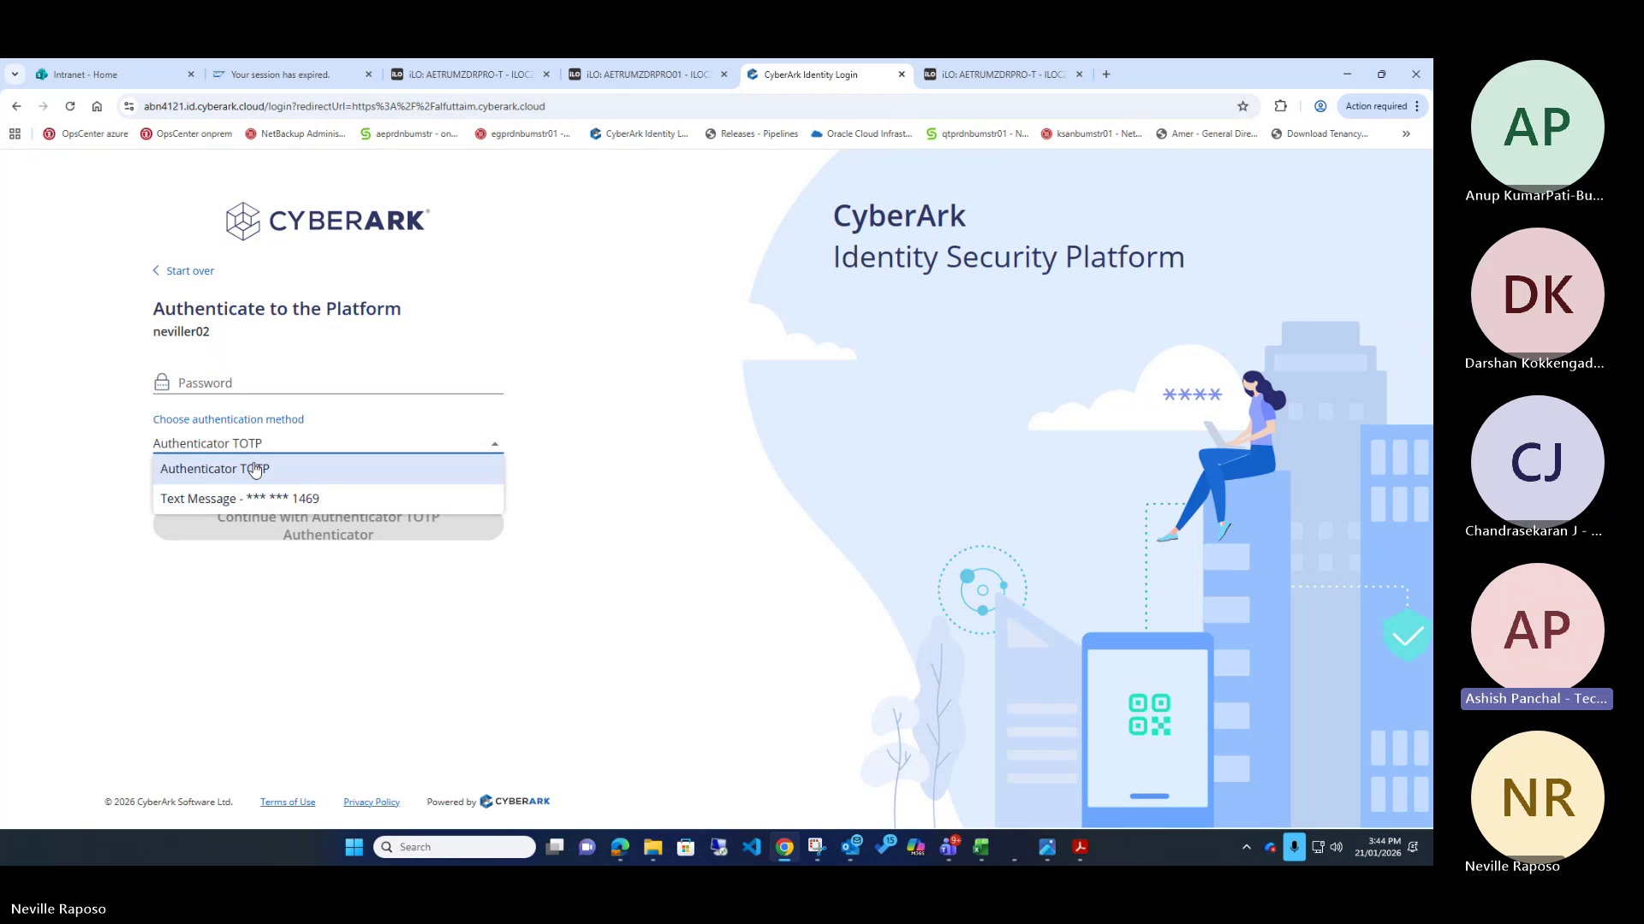
The administrator specifies the relevant database tables for mapping purposes, configuring the necessary parameters.

Step 5
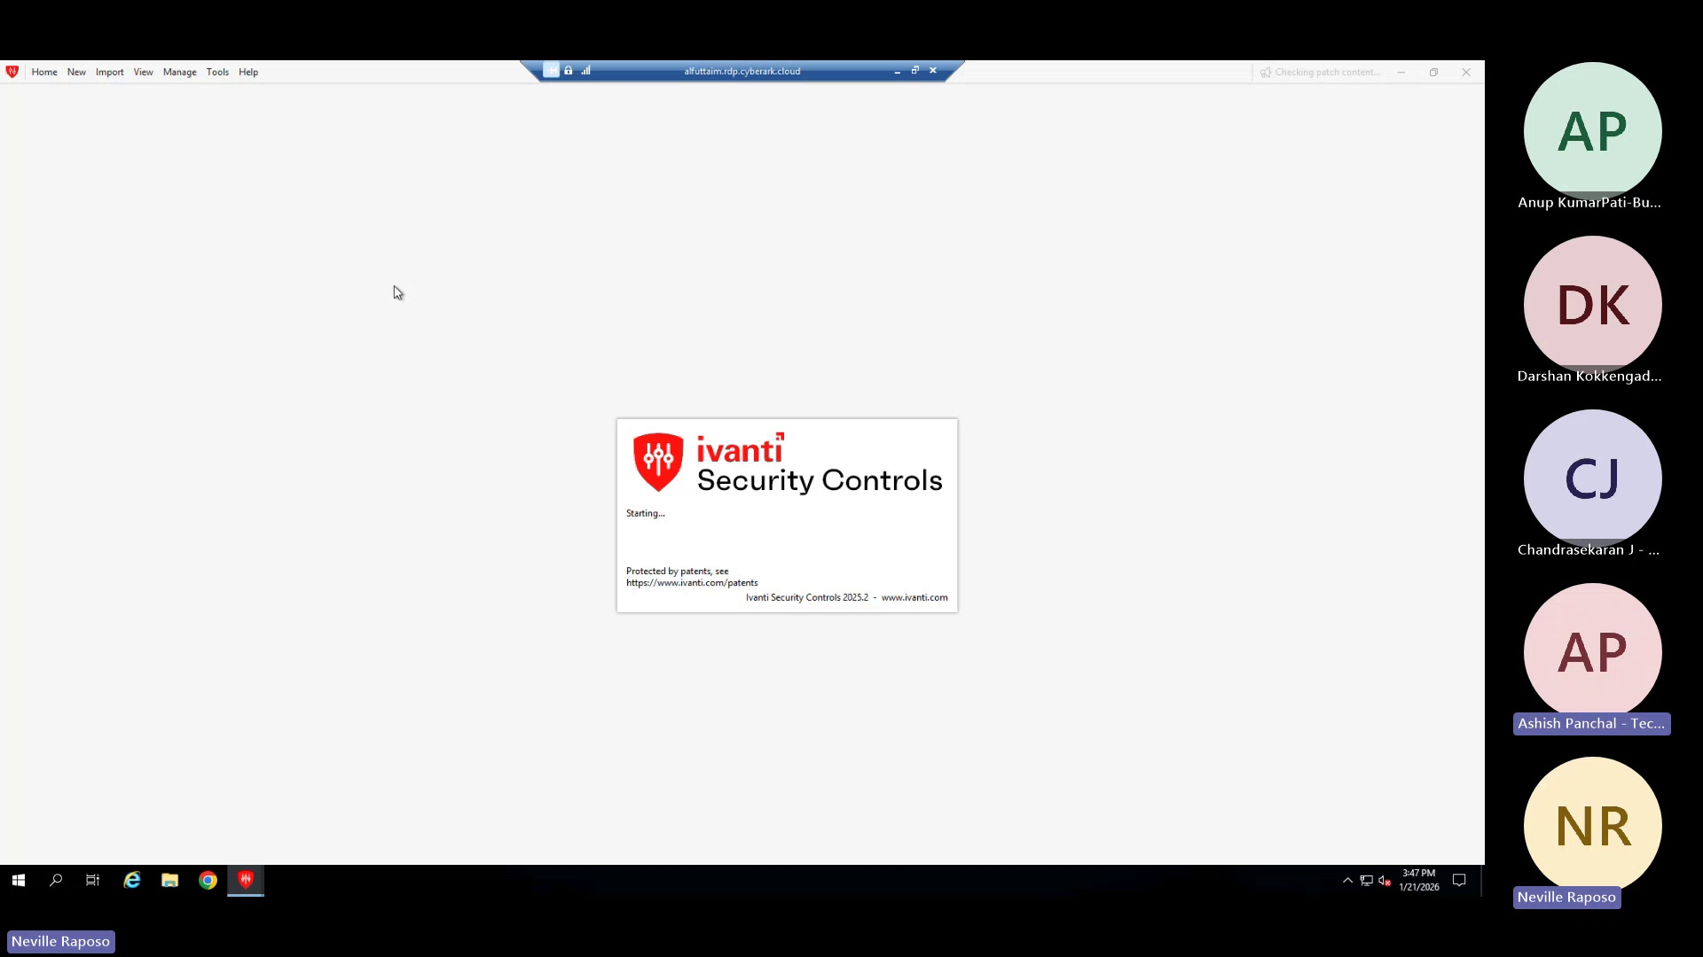
The individual enters their password for a standard account that has been assigned the required privileges and access rights.

Step 6
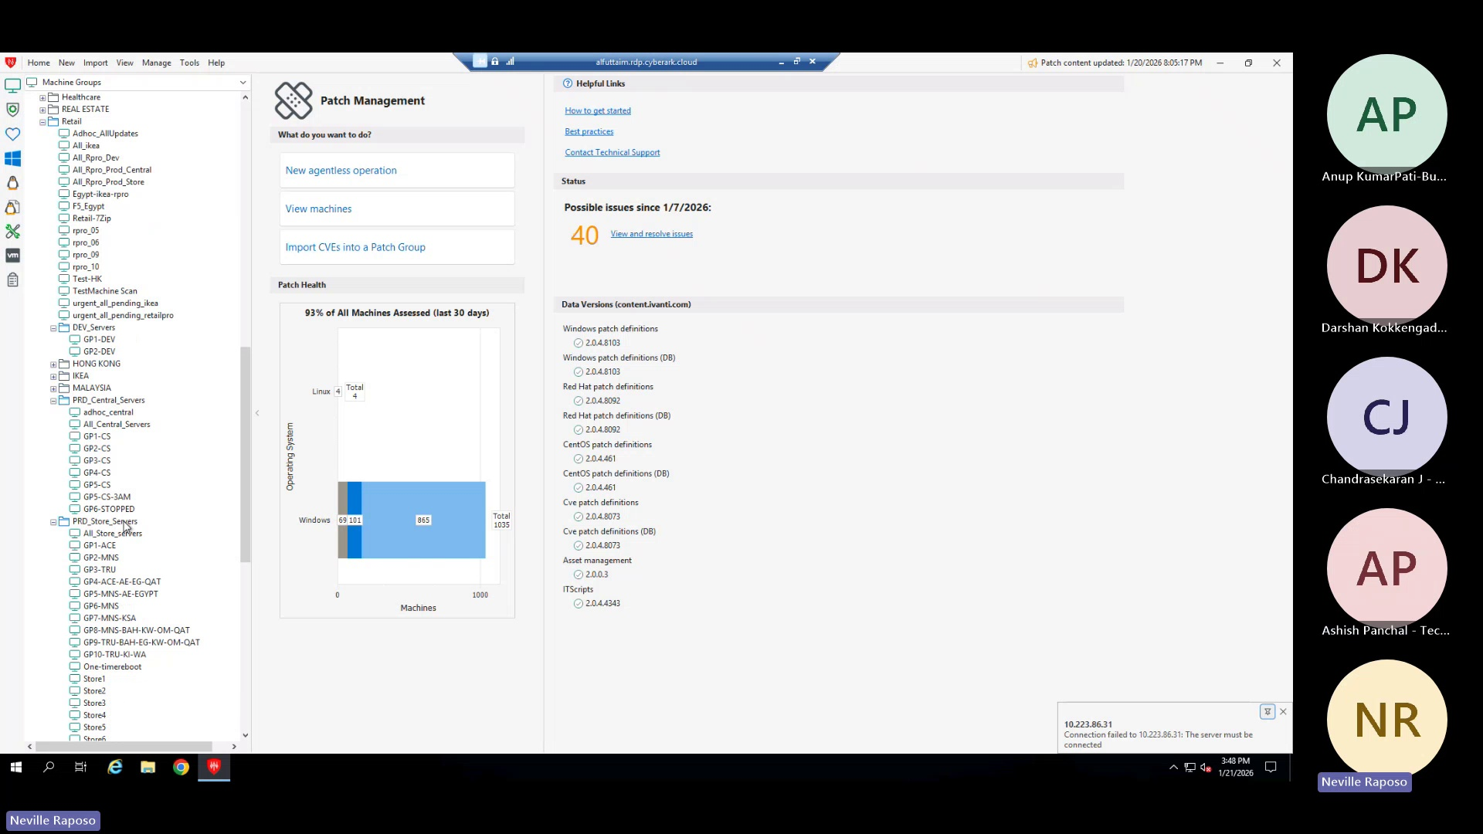
The user navigates through the system to review predefined groups and related settings, as configured by the administrator.

Step 7
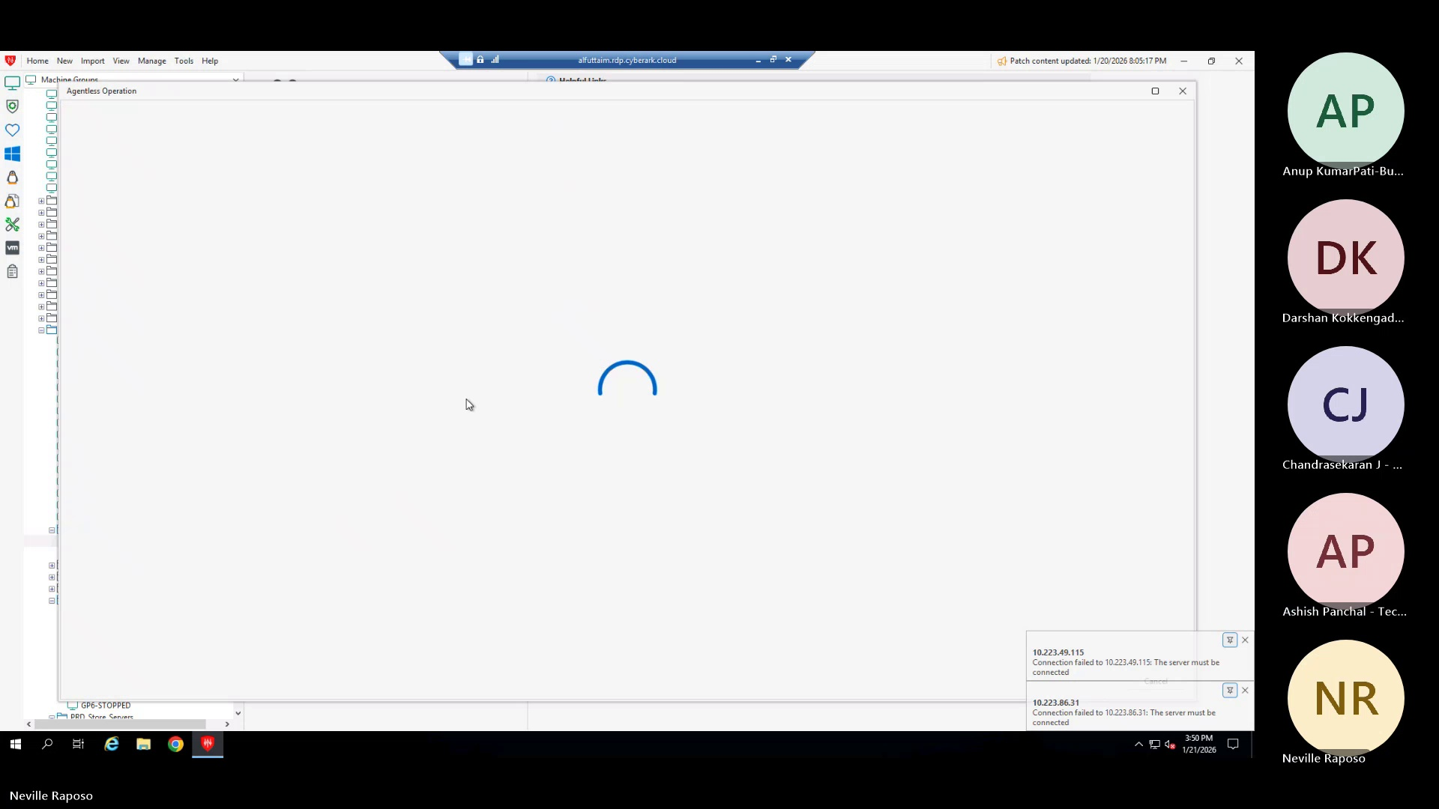
Note: I corrected "Eventy" to "system administrator", assuming it was a transcription error. Also, I changed "key action" to more descriptive verbs like "initiates", "determine", "specifies", etc. to make the language more concise and professional.

Step 8
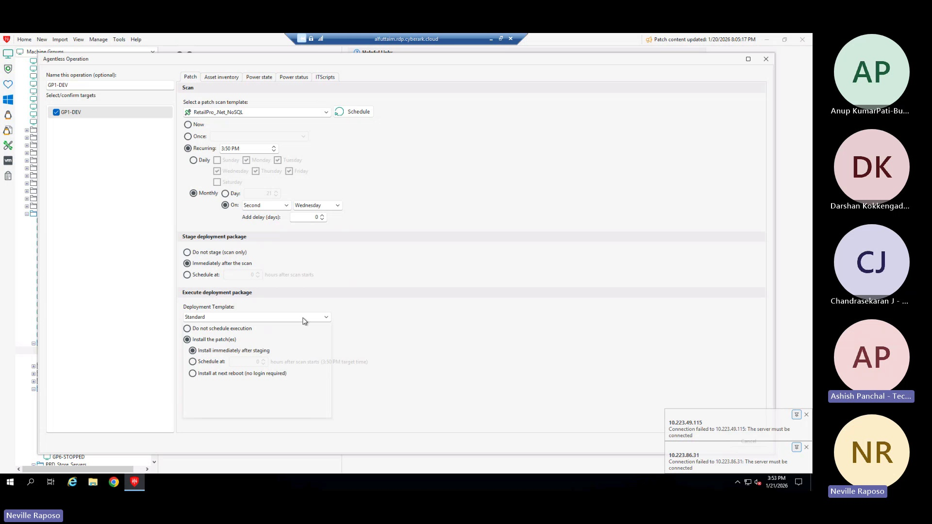
Here are the revised step descriptions:

Step 9
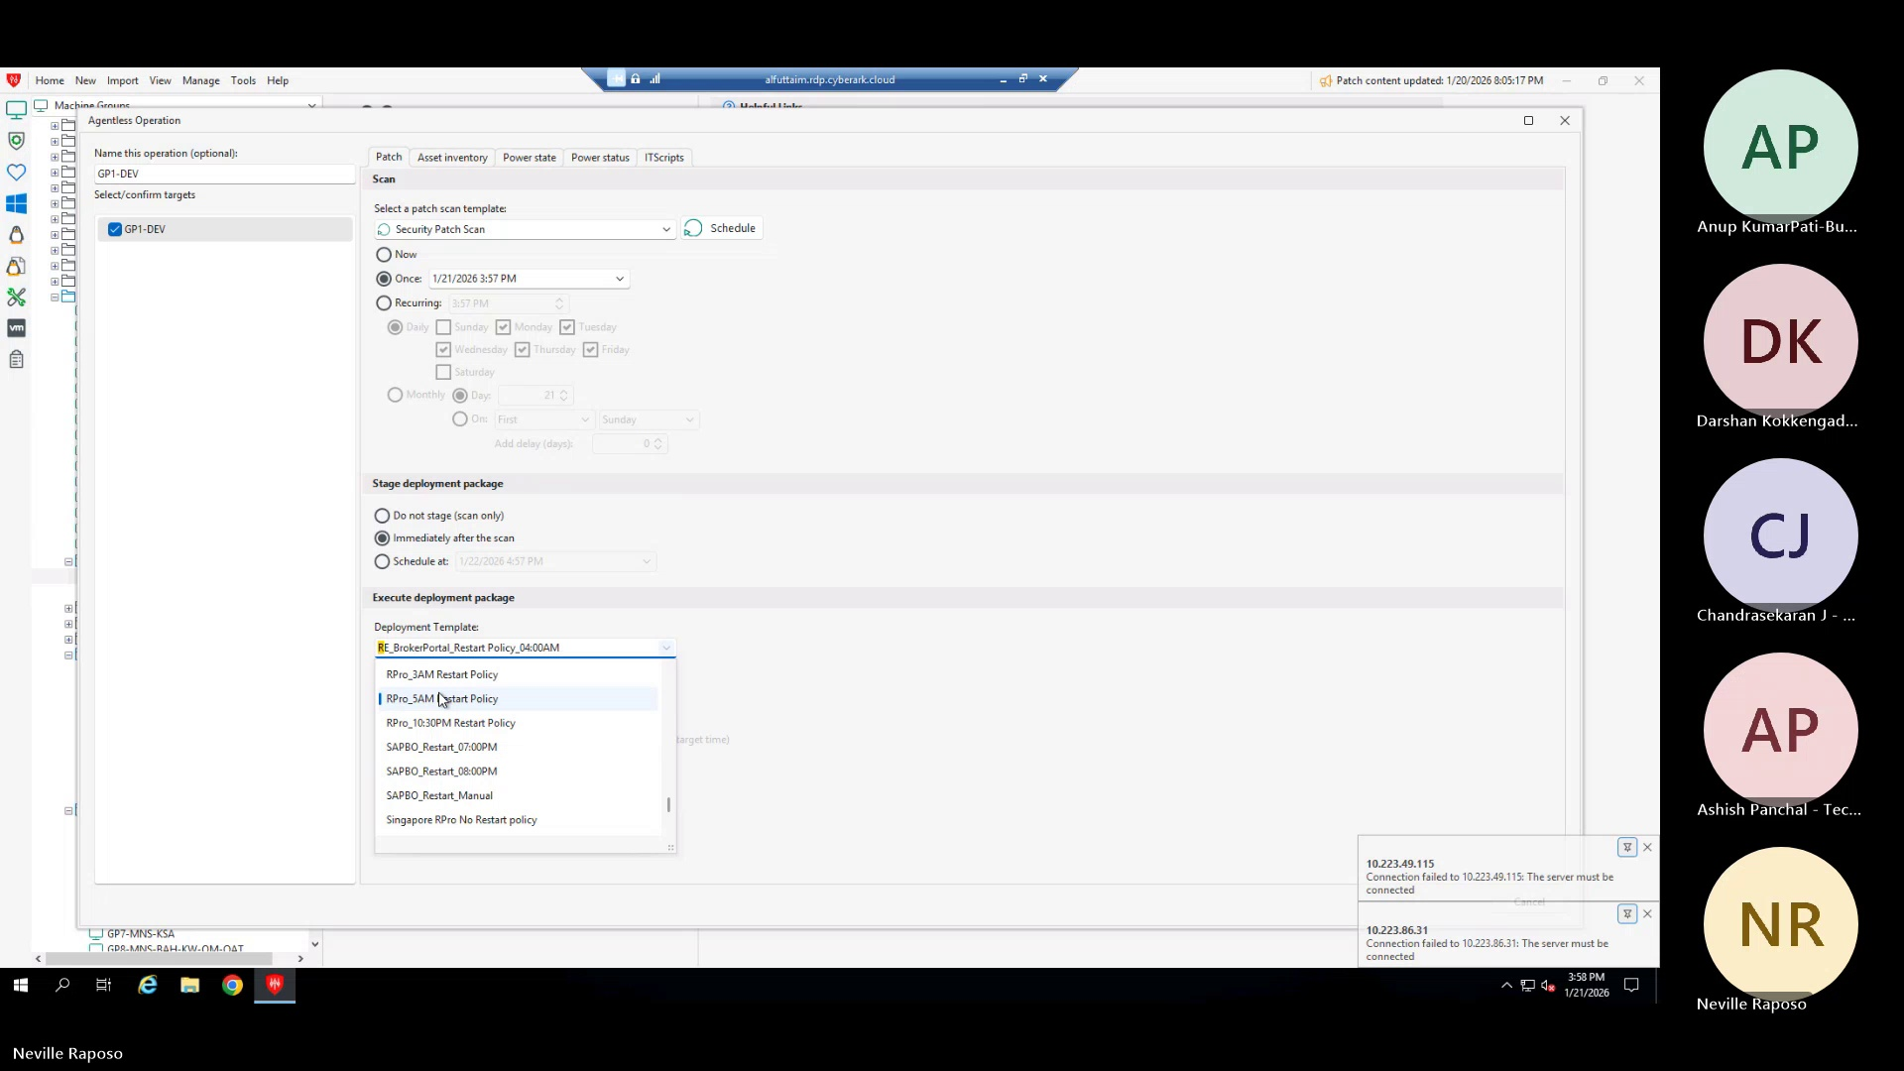
The user configures development central servers by specifying relevant groups.

Step 10
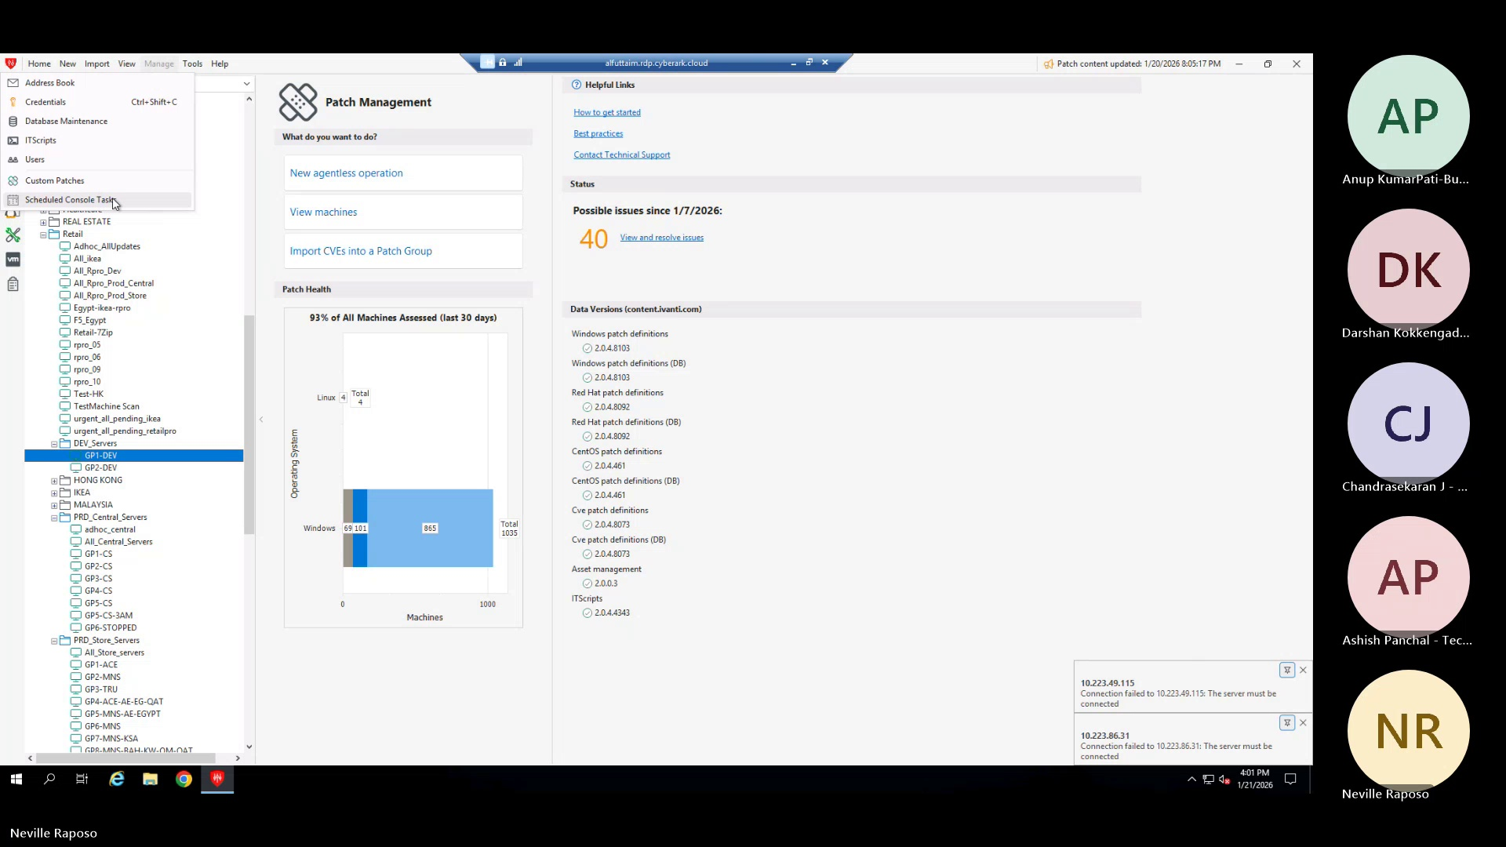
The user executes a template against a predefined group of users or roles.

Step 11
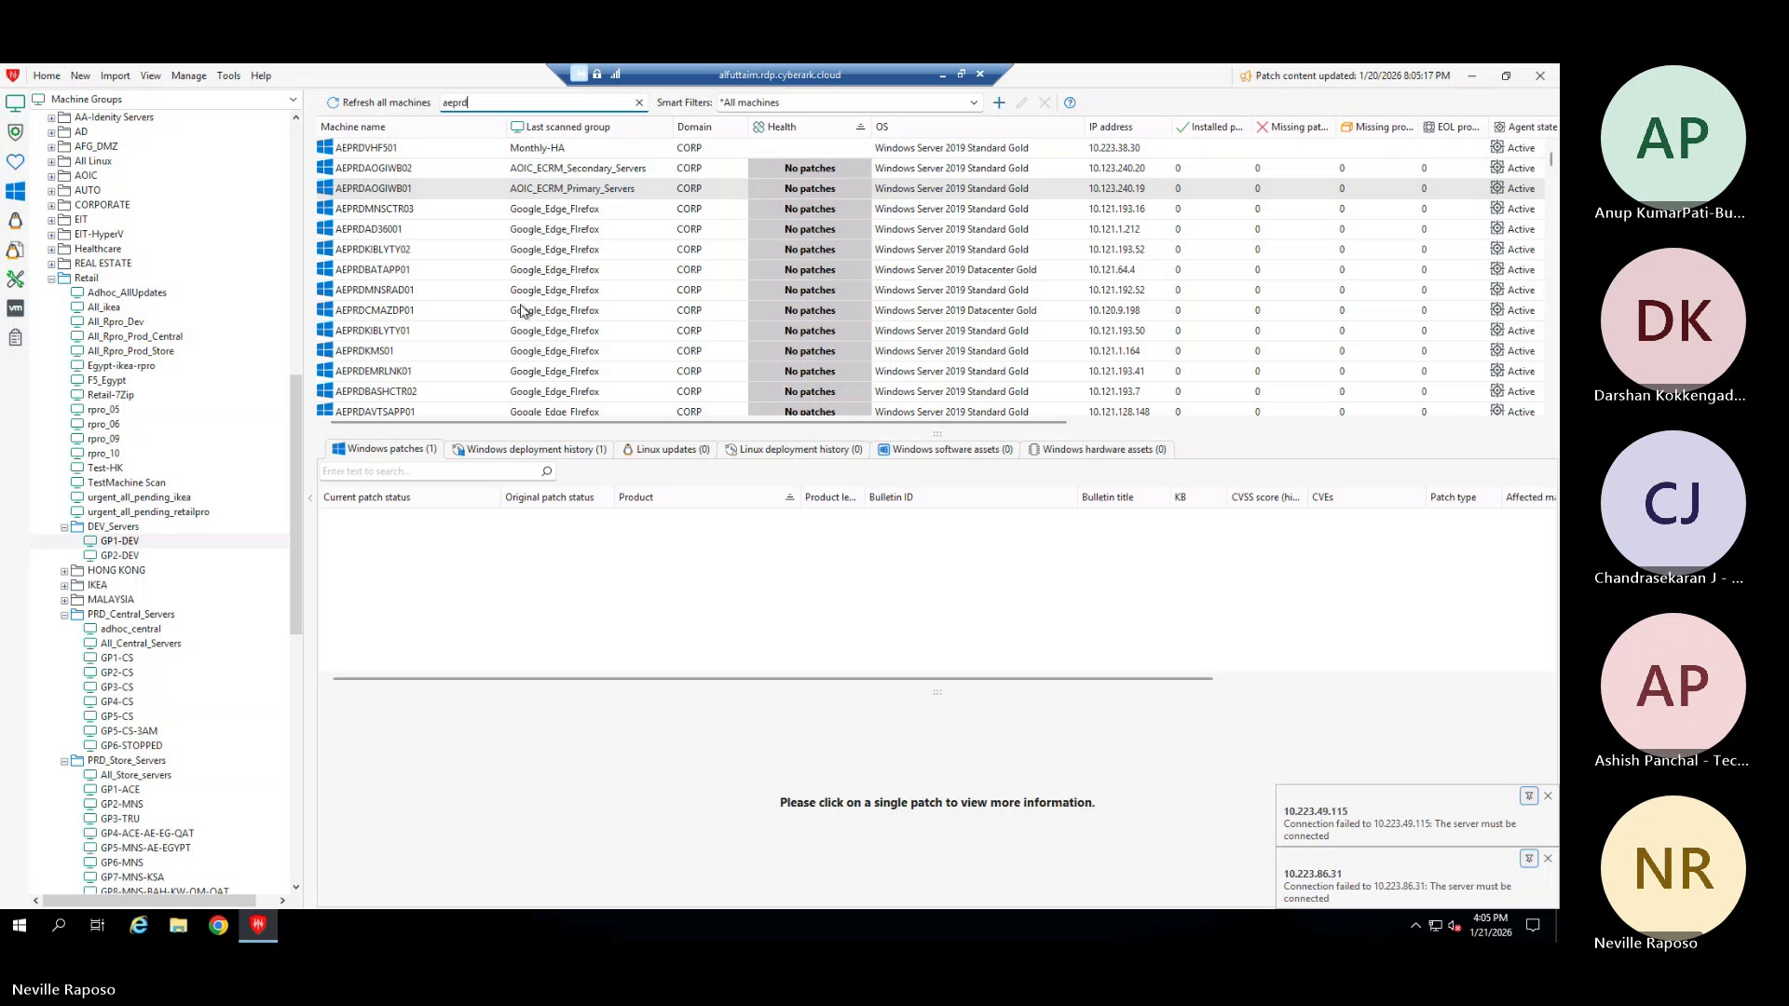
The system schedules an automated server restart for a specified time.

Step 12
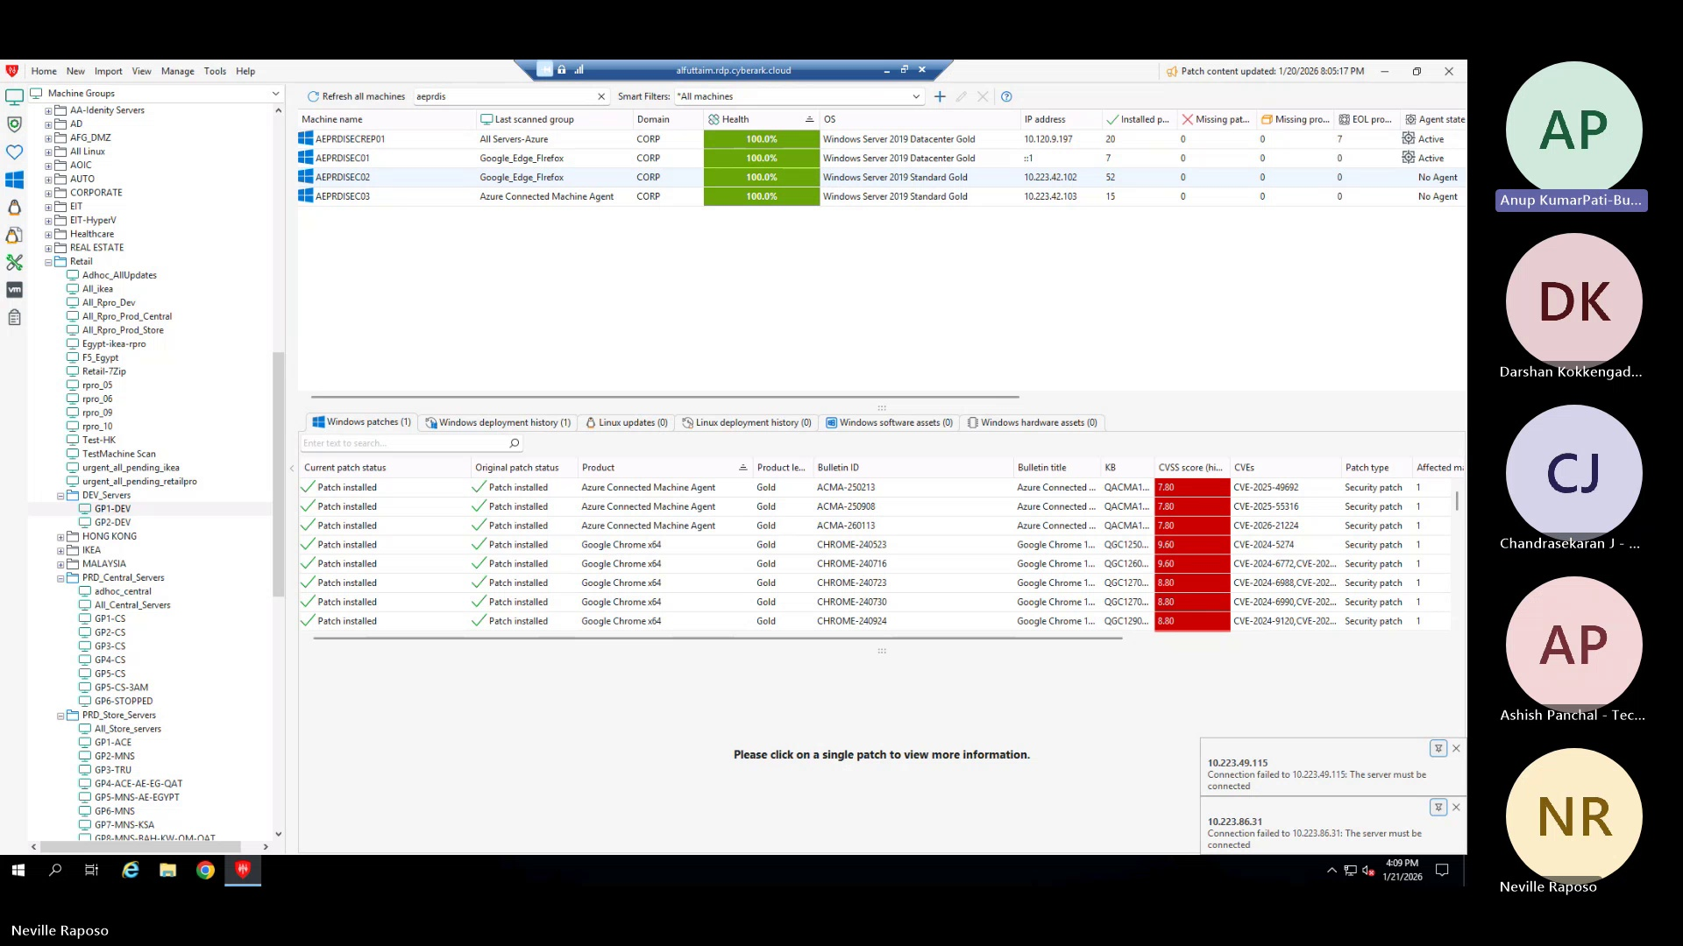
The developer reviews and documents potential failure cases and corresponding remediation actions.

Step 13
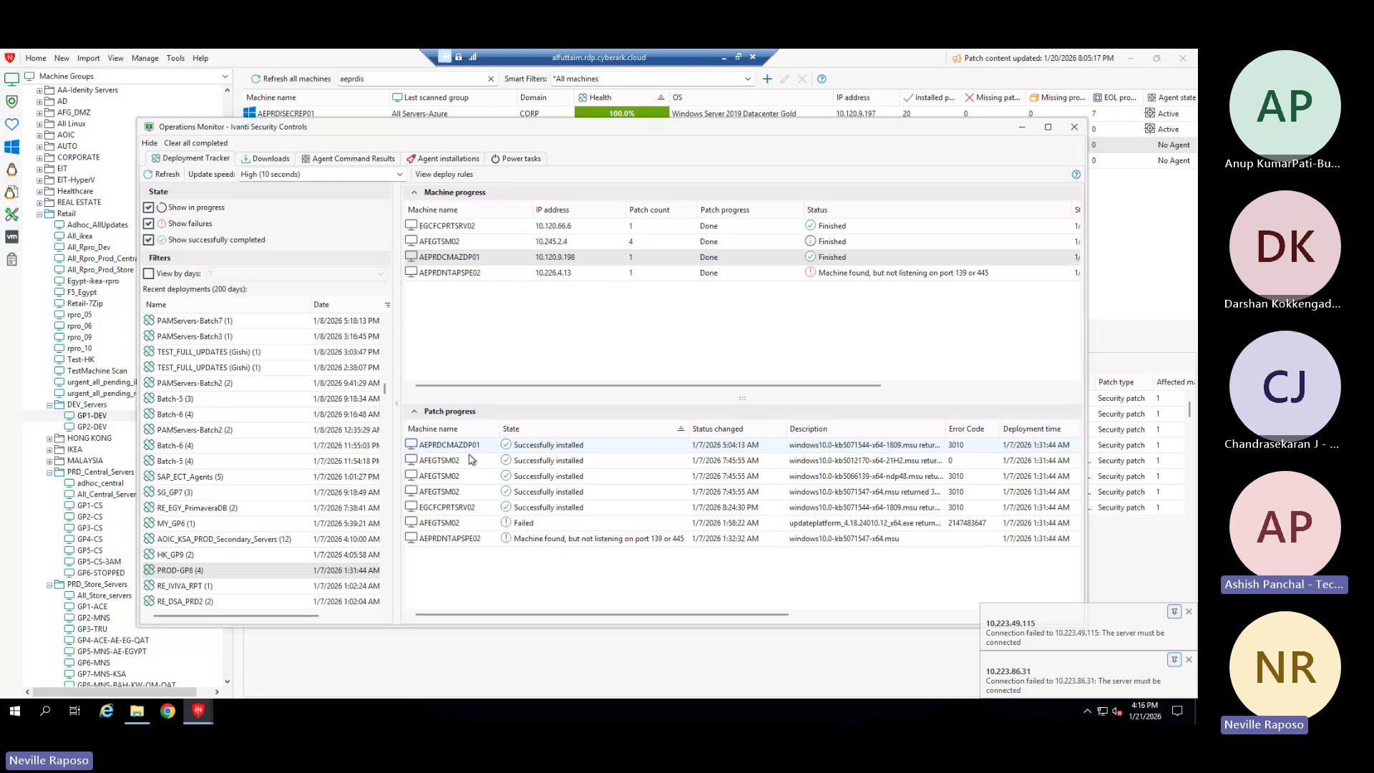
The administrator navigates to the deployment records to view deployment history.

